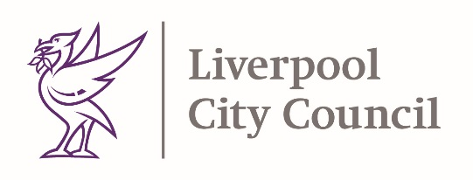

Dear Resident,

I am writing to ask you to take extra care as someone who has previously needed to shield. In Liverpool our COVID-19 positive cases are high and have been rapidly increasing over the last week. The total number of confirmed cases in the last 7 days is 303, an increase of 212 cases on the previous week.

Whilst this recent raise in cases has mostly been in people under age 40 - anyone can get COVID-19 at any age. People with health conditions and those who were asked to shield are still particularly vulnerable and need to take special care during this worrying period and to be extra cautious when making decisions to socialise, avoiding crowds and going places that are not COVID-19 secure.

To protect yourself and others, when you leave work or your home, you must always:
- Ensure stringent social distancing - stay at least 2 metres away from anyone you do not live with or who is not in your support bubble

- Limit your social contacts – being mindful of the widespread virus transmission

- Wash your hands with soap and water often, and as soon as you get home - use hand sanitiser gel if soap and water is not available
- Wear a face covering over your mouth and nose where social distancing is not possible outdoors and indoors. By law, you must now wear them in most indoor settings including public transport, shops, post-offices, banks, beauty salons, visitor attractions and entertainment venues, libraries, community centres, places of worship and public areas in hotels

- Avoid crowded environments where the risk of transmission is higher

- Avoid businesses that are not COVID-19 secure (including pubs, cafes and restaurants) If they are not looking after you, don’t go there!

Start now!
Government has advised that from Monday, 14 September, we all must avoid social gatherings of more than six people inside and outside our homes. I would urge you to start doing that immediately and consider limiting your social contacts as much as possible during this period.

What to do if you develop symptoms?
If you develop symptoms such as a cough, or fever, or you lose your sense of taste or smell, get a test and stay at home until you get the result. You can book a test by going to www.nhs.uk/coronavirus or call 119 if you do not have internet access. If you test positive, please stay at home for 10 days from when your symptoms have started. If you are contacted by NHS Test and Trace, follow their instructions.

What if you need help to self-isolate?
Now is the time to think about who would support you if you can’t go out. Who will be able to help you get your shopping and essentials? Ask your family, friends or neighbours if they can help – have a plan.

Liverpool City Council have established an Isolation Advice Line to help people who have been asked to self-isolate and have NO means of support from friends, family, or neighbours, to remain at home. Get in touch if you need help with:
• Shopping
• Emergency Foodbanks
• Collecting Prescriptions
• Or just having a friendly voice just to speak to

Our advice line 0151 233 3066 is open 8am to 6pm Mon-Fri. An online form is also available 7 days a week at https://liverpool.gov.uk/covidsupport

We all need to play our part in preventing further spread of COVID-19 in our city.

Please keep yourself and others safe.

Yours Sincerely

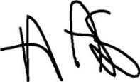

Matthew Ashton
Director of Public Health

A COVID Secure Business is one that is actively implementing the UK Government Covid Secure Guidelines to control the risks from COVID-19 to staff, visitors and customers. Further detailed guidance for business sectors can be found at: https://www.gov.uk/guidance/working-safely-during-coronavirus-covid-19

